<Title of the report>

Student technical report – “Interactive Simulation Systems” course

Manuel Hernández Nájera-Alesón  
January, 29th, 2018

Supervisor: Siniša Popović

***Abstract* – Memory development under stress is a useful capacity for human beings. In this project It will be measured through a demanding task.**

# Introduction

Spatial memory has always been crucial for humankind when performing either 2 or 3-dimensional work. We depend heavily on our way of understanding and interacting with space and, of course, our way of remembering It’s setting.

The aim of this project is to evaluate how different human beings can interact with 2D environments while under a situation of sudden stress caused by a fast-paced task accompanied by loud and screaky noises.

The individual will switch from a tranquil and low-demanding environment, in which they will be able to walk and see around the formerly mentioned task, which they will have to complete in a limited amount of time under extremely harsh circumstances.

This will allow us to measure the individual’s capability to handle sudden and stressful situations (e.g. surgery, aviation) and their efficiency whilst performing it.

There are some examples of spatial working memory tests [1].

The project has been developed with Unity 2017.2.0f using scripting language C# and Visual Studio IDE.

# Unity approach

When thinking about the best approach to this project realization, It came out that an already-built game-development-engine would be the best option. After considering other alternatives, Unity was the most suitable option.

Unity is a multiplatform videogame engine, available for Microsoft Windows, OS X and Linux. It provides the developer with a compilation support with a wide range of platforms, a graphical engine, a physical engine and a complex object hierarchy.

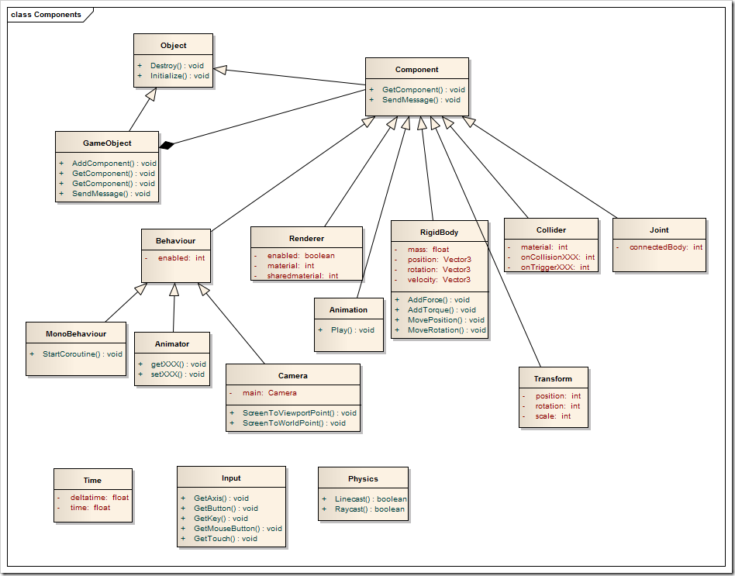

Figure 1. Basic Unity GameObject structure example. [1].

Unity was the best approach to this problem as it consists of a set of scenes that allow .

If the report dominantly represents the review of the literature on a particular topic, then the concept of the report is, of course, different. During the extraction and synthesis of text from various literature sources, and insertion of the text in the essay, the authors should ensure that the text has a clear organization that is reflected in the titles of the sections. In this sense, the texts you read from various sources may be necessary to reorganize, to obtain a clear structure of the report. Number of literature sources should be considerably richer than in the practically oriented report; typically a couple of dozen sources are expected. Literature review is more than just extraction of important parts of text from these sources, but also includes synthesis and organization of the findings in order to best address the purpose of the authors’ report. It is not uncommon to have tables of the reviewed works, in which findings are organized according to the criteria that are important for the authors’ topic of the report.

## <Subsection 2.1>

This is a specific section which depends on the topic that is being discussed in the report. Therefore, it should be given an appropriate title and its body should contain appropriate text and images. Of course, whether the report will have subsections or not is the author’s decision.

# <Section 2>

This is a specific section which depends on the topic that is being discussed in the report. Therefore, it should be given an appropriate title and its body should contain appropriate text and images. There can be more than one such section.

Each figure and table should be referenced in the text where it is being described, typically like this (Figure 1). Figures and tables are referenced in the text before they appear.



Figure . Example of a figure. Both grayscale and color figures are appropriate, but color figures should be printed in color when handing in the report. If figure is taken from some source, please indicate this by putting the source in the References section and by stating its reference number in the figure caption, e.g. [1].

If the report describes some practical work, rather than literature review, this section and other specific sections describe the methods (your approach to solving the problem and rationale underlying your decisions – materials, models, architecture, design, implementation, interfaces, tools etc.), results obtained by solving the problem, discussion of the results (what do results mean, limitations of the results, potential generalizations of the results outside of the scope in which they were obtained …). Some particularly interesting source code excerpts, pseudocode of the algorithms etc. may be included in the main text of the report, in the form of figures. Particular attention should be paid to the fact that the report is not just description of functionality for the user and how the user can work with the developed solution; rather, the report should also include explanation of key things for understanding how your solution was designed and developed from the technical, engineering standpoint, what are the key components and how these components mutually interact in the developed solution. Key components from the design and development side can be related to: classes in the object-oriented model, processes/threads if concurrency is involved, potential specific algorithms which were used in implementation of key parts of the solution, structures of input/output data/files, database model, organization of source code files etc. In this sense, it is common and expected to see some technical diagrams and descriptions, like class diagrams, state machines, flow diagrams, interaction diagrams in Unified Modelling Language (UML), description of the structure of communication messages, entity-relationship models, algorithm pseudocodes etc.

If the report dominantly represents the review of the literature on a particular topic, then the concept of the report is, of course, different. During the extraction and synthesis of text from various literature sources, and insertion of the text in the essay, the authors should ensure that the text has a clear organization that is reflected in the titles of the sections. In this sense, the texts you read from various sources may be necessary to reorganize, to obtain a clear structure of the report. Number of literature sources should be considerably richer than in the practically oriented report; typically a couple of dozen sources are expected. Literature review is more than just extraction of important parts of text from these sources, but also includes synthesis and organization of the findings in order to best address the purpose of the authors’ report. It is not uncommon to have tables of the reviewed works, in which findings are organized according to the criteria that are important for the authors’ topic of the report.

## <Subsection 2.1>

This is a specific section which depends on the topic that is being discussed in the report. Therefore, it should be given an appropriate title and its body should contain appropriate text and images. Of course, whether the report will have subsections or not is the author’s decision.

# Conclusion

Provide conclusions of your work and suggestions of avenues for future work, regardless of whether the report is mostly related to literature review or practical work.

# References

[1] Wang Xuanyi, Unity verview of basic concepts [online]

<http://www.programering.com/a/MDO4UDNwATY>**.**

[2] Cambridge Cognition, Spatial Working Memory

http://www.cambridgecognition.com/cantab/cognitive-tests/memory/spatial-working-memory-swm/

[3] D. S. Lee and J. G. Fossum, “Energy Band Distortion in Highly Doped Silicon”, IEEE Transactions on Electronic Devices, vol. 30, p. 626, 1983.

[4] D. B. Payne and J. R. Stern, “Wavelength-switched passively coupled single-mode optical network,” in Proceedings of *IOOC-ECOC*, 1985, pp. 585–590.

[5] G. Brandli and M. Dick, “Alternating current fed power supply,” U.S. Patent 4 084 217, Nov. 4, 1978.

[6] E. E. Reber, R. L. Mitchell, and C. J. Carter, “Oxygen absorption in the Earth’s atmosphere,” Aerospace Corp., Los Angeles, CA, Tech. Rep. TR-0200 (4230-46)-3, Nov. 1968.

[7] J. Jones. (May 10, 1991). Networks. (2nd ed.) [Online]. http://www.atm.com. Accessed: February 14, 1999.

[8] S. L. Talleen. (June 1996). The Intranet Architecture: Managing information in the new paradigm. Amdahl Corp., CA. [Online]. http://www.amdahl.com/doc/products/bsg/  
intra/infra/html. Accessed: June 8, 1998.

# Appendix

Appendix is an optional part of the report. It is intended for a larger number of similar figures which, if included in the body of the report, would significantly disrupt the flow of text, as well as for multi-page algorithm listings, larger proof derivations etc.